**1.LinkedIn Account**

LinkedIn is a professional networking platform where I maintain a detailed profile that highlights my academic achievements, skills, and career aspirations. This platform allows me to connect with industry professionals, join relevant groups, and stay updated with the latest trends in my field.

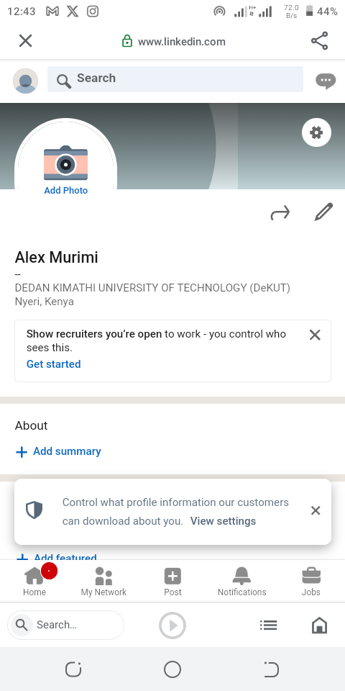

**2.Twitter Account**

Twitter is a platform where I actively engage with the community by sharing updates, insights, and relevant news related to Computer Science. My account reflects my professional interests and allows me to participate in industry conversations.

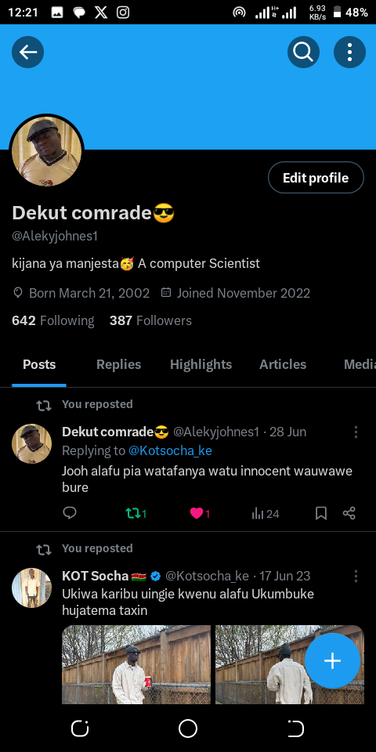

**3.Instagram Account**

On Instagram, I share visual content related to my academic projects, personal interests, and professional experiences. This platform allows me to connect with a visually-oriented audience and showcase my journey in a more engaging format.

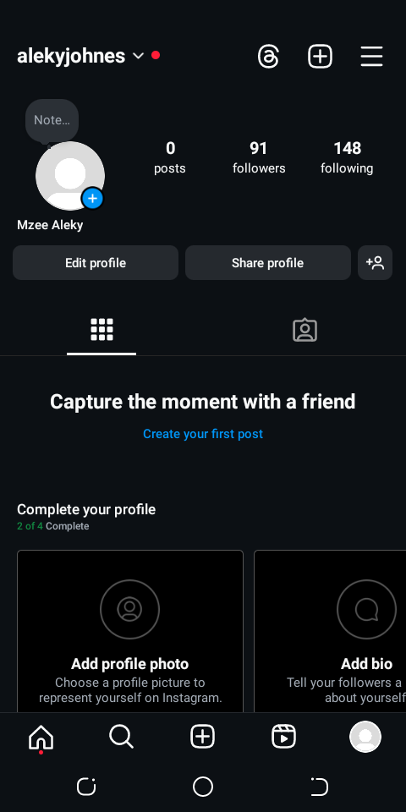

**4.WhatsApp Account**

WhatsApp is a vital communication tool that I use for both personal and professional purposes. I am part of several professional groups where we share information, collaborate on projects about Computer Science, and provide support to each other.

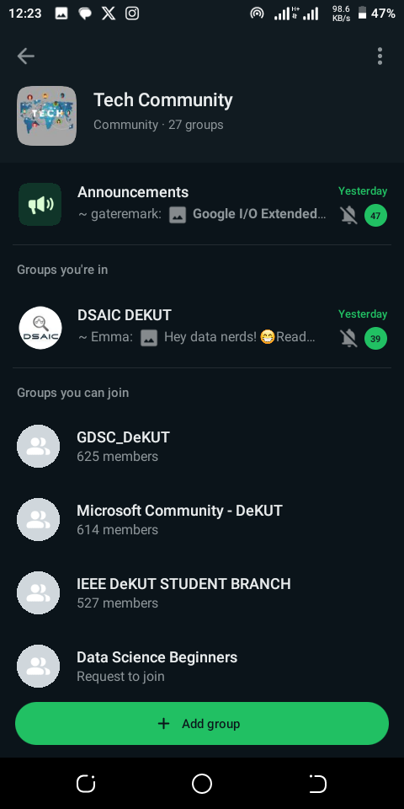

**5.Facebook Account**

Facebook can be a powerful tool for professional networking, sharing industry-related content, and participating in relevant groups. Below is an outline of how my Facebook account demonstrates professional relevance.

